**Executive Maturity Report**

*A focused summary to quickly inform the board about a recently conducted Maturity assessment*

# Executive Summary

* 80% of AI models are governed by documented policies
* 75% of Staff completes AI Governance training
* Average maturity rating across five core domains is **2.6 out of 5**

# Maturity Assessment Methodology

### Format

A 5-level Maturity model has been finalized after referencing existing models by NIST and WEF.

### Levels and Scores

|  |  |
| --- | --- |
| **Level** | **Score** |
| Ad-hoc | 1 |
| Repeatable | 2 |
| Defined | 3 |
| Managed | 4 |
| Optimized | 5 |

## Assessment Results

|  |  |  |
| --- | --- | --- |
| **Domain** | **Score** | **Evidence** |
| Policy | 3 | AI usage policies are documented and reviewed annually. |
| Ethics | 2 | Biases detected in 80% of models |
| Lifecycle | 3 | Quarterly transparency reports published organization-wide |
| Risk | 3 | AI usage policies are documented and reviewed annually. |
| Monitoring | 2 | Only basic task monitoring in place |

# Spider Chart Heatmap

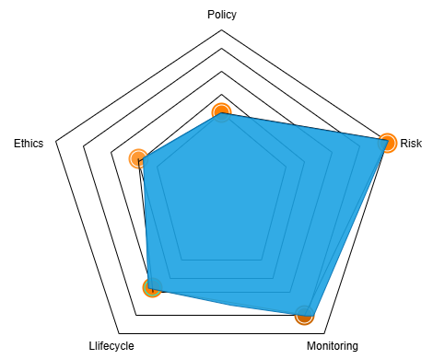

# 

# 

# 

# 

# 

# Action Plan

The action plan should aim to increase the existing scores across all domains.

|  |  |  |
| --- | --- | --- |
| **Domain** | **Existing Score Reason** | **Improved Score Actions** |
| Policy | Basic AI policy exists, but lacks detailed procedures and regular updates | Develop comprehensive, regularly reviewed AI policies; involve key stakeholders in updates |
| Risk | Ideal risk management practices | Periodically evaluate effectiveness and strive to improve impact of risk assessments |
| Monitoring | Monitoring is manual and only done after issues arise | Deploy automated monitoring tools; set up regular reporting and proactive alerts |
| Lifecycle | Lifecycle management is informal; no clear documentation on AI model updates | Establish formal AI lifecycle processes with version control and audit trails |
| Ethics | Ethics considerations are discussed but not formally documented or enforced | Develop an AI ethics framework; provide training and integrate ethics reviews into workflows |

**END**